1. Certification Tracking & Expiry Alerts Module
The dept maintains many product-related certificates (60) which must be renewed periodically. Currently, this is being tracked manually. To avoid missing renewal dates, they require a section in the ERP where:
- TCS Comment: Client wants to track all the Quality Certificates (roughly 72+ certificates) along with PDF copies. Additionally, a single mail should trigger from the system before the due date of the certificate. TCS team will check for any workaround and update

- Alternative (until TCS gives a definite reply): Maintain a Google Sheet and Use Apps Script to calculate expiry and send automated email reminders.eg with test data –

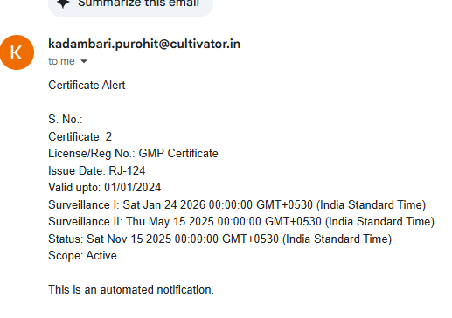
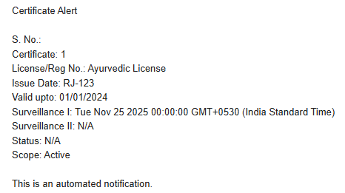

2. Product Certification Status
Dept also needs an easy way to see which products are certified under which standards.
TCS Solution: Use the Comment field in the Item Master to mention the required categories. (Note: There is a limitation on the number of characters.) This comment can be viewed during Quality Test via the “i” popup in front of the Item Description

Manufacturing>> Master>>item Detail
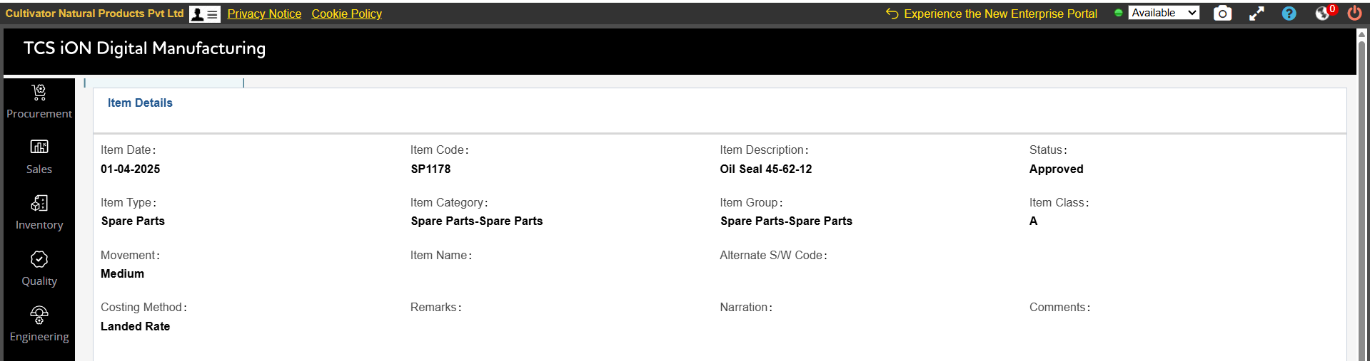

3. Label Design History (Can be added where product list is shown)
Label designs (box designs) change frequently based on client requirements. They want a simple view where:
- Past label designs of each product
- Current active design
- Upload history
are visible in one place.
- TCS Comment: Tracking changes in outer box design by uploading PDFs is not feasible in ERP.

